**W5-S2** PRACTICE

*FORMS & INPUTS*

## *What are the objectives for this session?*

* Learn and use various **HTML form input types**
  + *text, checkbox, radio, dropdown, text area, range, color, selector etc.*
* Apply basic CSS styles to enhance the appearance of form inputs
  + *borders, colors, padding, margins etc.*
* Use:  **:focus :hover** : **checked :checked :indeterminate** CSS pseudo-classes

## *How to start?*

* Download **the start code** from the LMS
* Open the folder in VS Code

## *How to submit your work?*

* **Push** your final codeon **your GitHub repository**
* Then **attach the GitHub path** to the MS Team assignment and **turn it in**

## *Are you lost?*

*You can read the following documentation to be ready for this practice:*

* [Guide - WC3 School](https://www.w3schools.com/html/html_forms.asp)
* [The Form element](https://developer.mozilla.org/en-US/docs/Web/HTML/Element/form)
* [HTML Forms](https://www.geeksforgeeks.org/html-forms/)

# **PART 1:** LEARN – 45 MIN

* **Read or watch** resources on internet to learn about **HTML Inputs**:

[Guide - WC3 School](https://www.w3schools.com/html/html_forms.asp)

[The Form element](https://developer.mozilla.org/en-US/docs/Web/HTML/Element/form)

[HTML Forms](https://www.geeksforgeeks.org/html-forms/)

* **Complete** the bellow table.

|  |  |  |
| --- | --- | --- |
| **INPUT TYPE** | **USAGE** | **EXAMPLE** |
| Text | defines a one-line input field for text input | <input type="text"> |
| radio | Define a radio button. | <input type="radio"> |
| checkbox | Define a checkbox. | <input type="checkbox"> |
| range | defines a control for entering a number whose exact value is not important. | <input type="range"> |
| submit | defines a button for **submitting** form data to a **form-handler**. | <input type="submit"> |
| textarea | defines a multi-line input field | <input type="textarea"> |
| select | Define the available option in drop down list. | <input type="select"> |
| color | is used for input fields that should contain a color. | <input type="color"> |
| file | defines a file-select field and a "Browse" button for file uploads. | <input type="file"> |

r

* **Read or watch** resources on internet to learn about  **Inputs styling**:

<https://www.w3schools.com/css/css_form.asp>

* Complete those **mini-challenges** by writing your code on bellow table:

|  |  |
| --- | --- |
| **MINI CHALLENGES** | **YOUR CODE (HTML + CSS)** |
| Highlight the input field when it is focused | <!DOCTYPE html>  <html lang="en">  <head>  <meta charset="UTF-8">  <meta name="viewport" content="width=device-width, initial-scale=1.0">  <title>Document</title>  </head>  <style>  input {  padding: 10px;  margin: 10px 0;  border: 2px solid #ccc;  border-radius: 5px;  }  </style>  <body>  <label for="text">Name:</label>  <input type="text" id="text" placeholder="Enter your name">  </body>  </html> |
| Change the button background color on hover | <!DOCTYPE html>  <html lang="en">  <head>  <meta charset="UTF-8">  <meta name="viewport" content="width=device-width, initial-scale=1.0">  <title>Document</title>  <style>  button{  color:black;  background: rgb(128, 67, 67);  width:100px;  height:50px;  border-radius: 5px;  }  button:hover{  background-color: azure;  opacity: 0.5;  }  </style>  </head>  <body>  <button>login</button>  </body>  </html> |
| Create a search bar with rounded corners and a shadow effect | <!DOCTYPE html>  <html lang="en">  <head>  <meta charset="UTF-8">  <meta name="viewport" content="width=device-width, initial-scale=1.0">  <title>search bar</title>  </head>  <style>  .search-container{  display: flex;  justify-content: center;  margin-top: 60px;  }  .search-bar{  width: 500px;  padding: 10px;  font-size: 15px;  border-radius: 15px;  border: 2px solid rgb(223, 214, 214);  outline: none;  }  .search-bar:focus{  border-color:rgb(49, 208, 49);  box-shadow: greenyellow;  }  .search-button{  margin-left: 10px;  border-radius: 15px;  border: none;  width: 100px;  background-color: goldenrod;  cursor: pointer;  font-size: 15px;  }  .search-button:hover{  background-color: rgb(16, 150, 16);  }  </style>  <body>  <div class="search-container">  <input type="text" class="search-bar" placeholder="You can search here">  <button class="search-button">Search</button>  </div>  </body>  </html> |
| Display a different style when the checkbox is checked |  |
| **HARD!**  Style a checkbox to have three states: unchecked, checked, and indeterminate.  TIP  Use CSS pseudo-classes  (:checked and :indeterminate)  for styling. |  |

* Some **groups will be selected to present** and **explain** their work to the whole class

# **PART 2:** PRACTICE – 45 MIN

You need to reproduce – *as close as possible* - the bellow table.

Before coding, identify the following point:

* **Elements**: What are the different inputs you will need?
* **Layout**: what kind of CSS layout do you need? Why?
* **Input styling**: What are the styles you need to apply on your inputs?

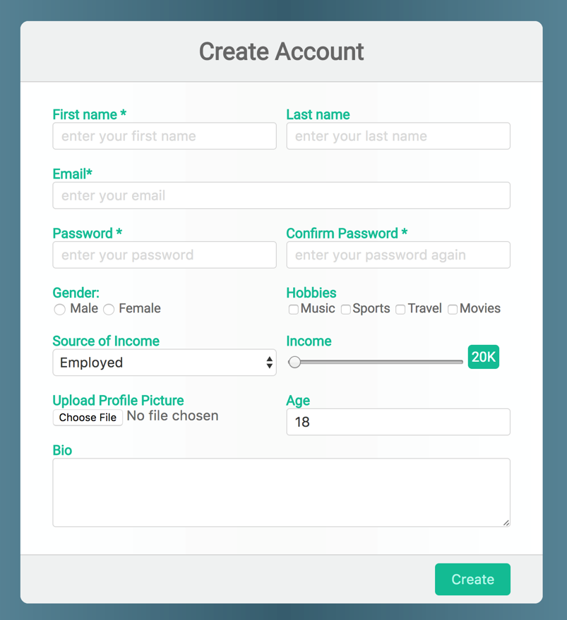

*Be as close as possible from this mock up*

# **PART 3:** THINK + PAIR + SHARE – 90 MIN

***STEP 1: INDIVIDUAL WORK*** *– 15 MIN*

1. Brainstorm a **form idea** based on a *scenario*

*e.g., contact form, login form, survey form, registration form…*

1. List the **elements** you think the form should include

*e.g.: text area, password, color selector, radio button, list…*

1. List any **specific CSS styles** the form should have

*e.g., hover effects, focus styles, alignment, layout, columns, rows…*

***STEP 2: COLLABORATIVE WORK*** *– 45 MIN*

1. Decide on a **single form idea** to develop.
2. **Sketch the form structure** and styling on paper
3. Start implementing the **HTML** structure and **CSS** styles collaboratively.

***STEP 3: SHARE*** *– 30 MIN*

* Pair with another team and demonstrates your project, explaining:
  + The **form’s purpose** and use case
  + How you structured the **HTML**
  + The **CSS** techniques used for styling
  + The **challenges you have faced** and how you resolved them
* Some **groups will be selected to present** their work to the whole class